Recommended Setup for Quick Access Toolbar

After completing the steps below, the Quick Access Toolbar will appear as:

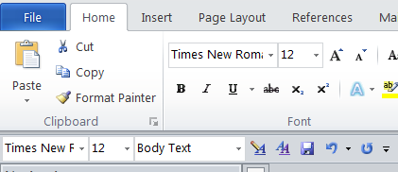

Click on *File*, then *Options*.

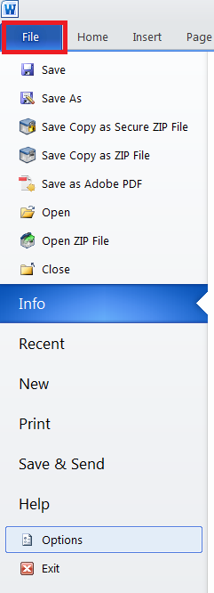

Click *Quick Access Toolbar*. In the dropdown menu under “Choose commands from,” select *All Commands*.

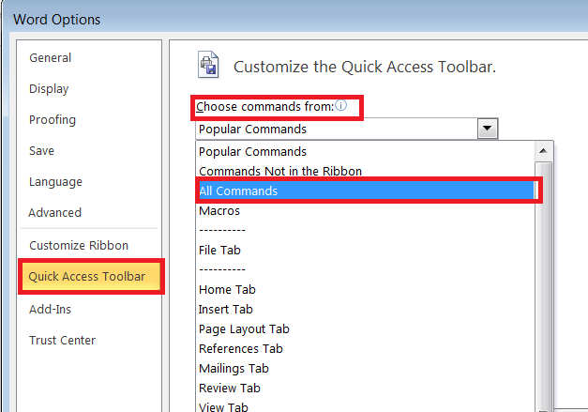

Select the following commands, clicking *Add* after selecting each.

*Font*

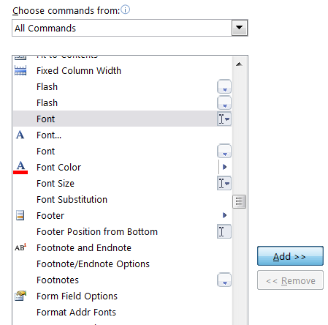

*Font Size*

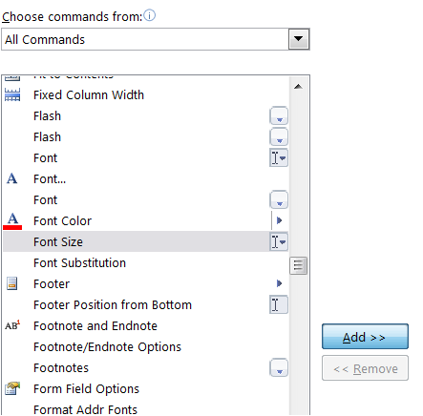

*Style*

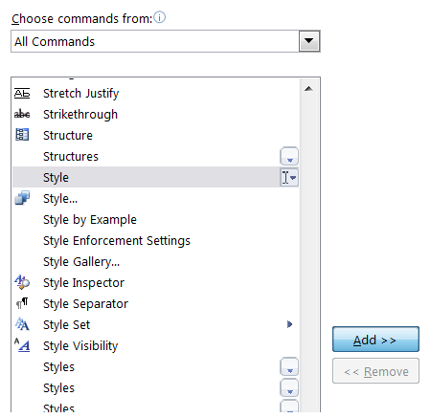

*Modify Style*

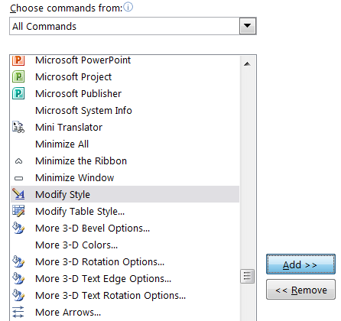

*Styles*

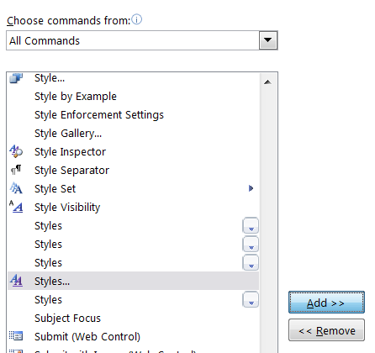

*Save*

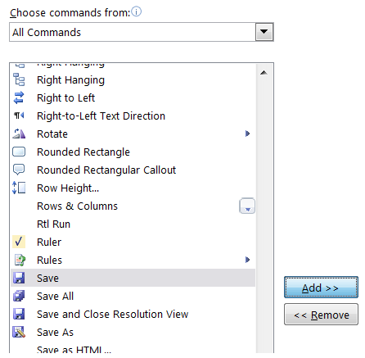

*Undo*

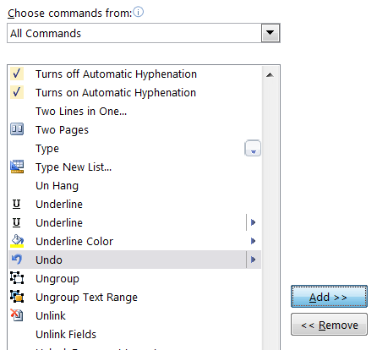

*Redo*

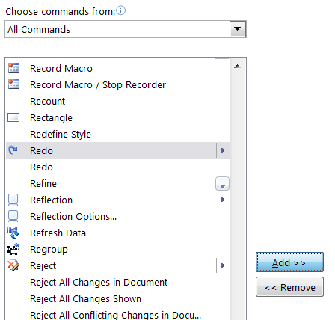

The elections under *Customize Quick Access Toolbar* will appear as:

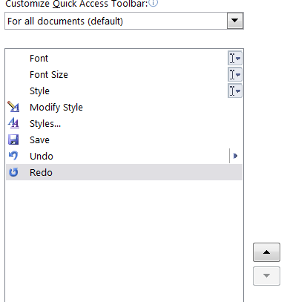

Ensure that the checkmark next to *Show Quick Access Toolbar below the Ribbon* is checked on, and click *Ok*

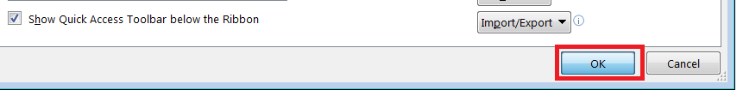

Recommended Setup for Field Shading

Click on *File*, then *Options*



Click *Advanced*, and scroll down to the section entitled “Show document content.”

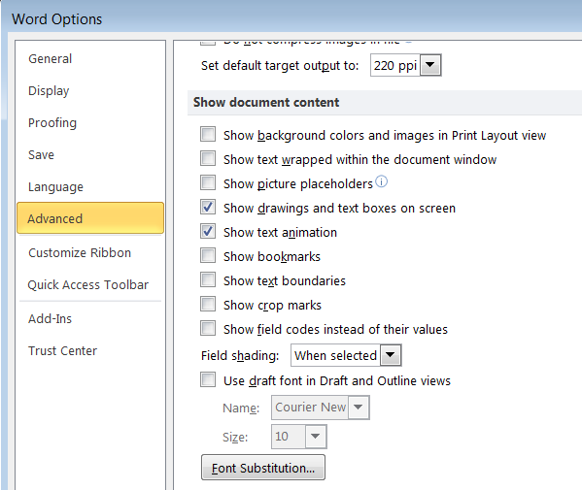

In the dropdown menu under “Field shading,” select *Always*.

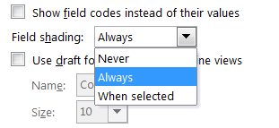

Click *Ok*.

